**A Restaurant Website With Bootstrap**

**Output**

**1.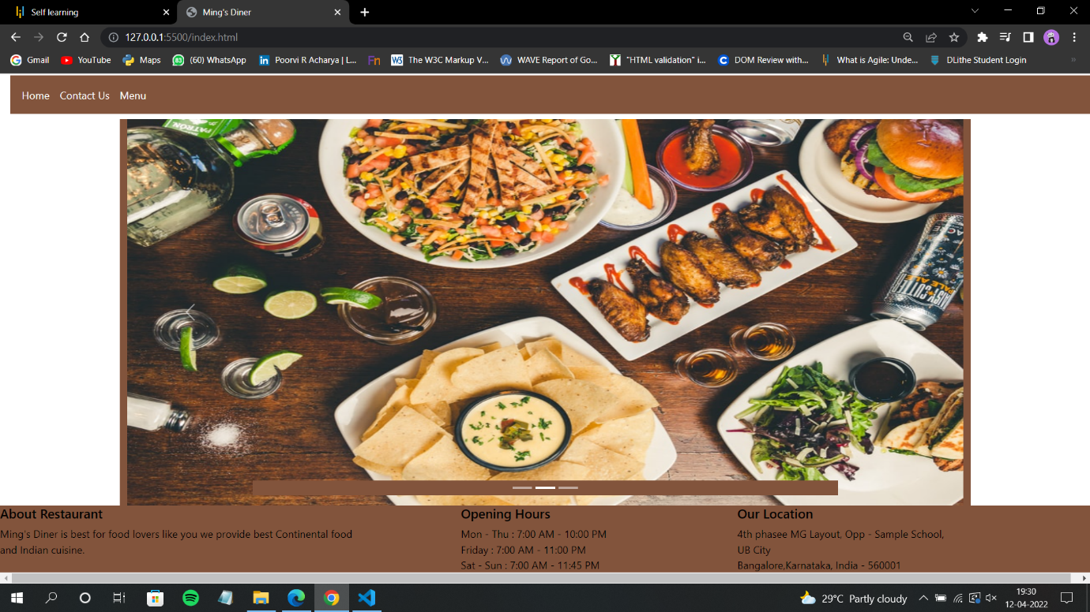 Home page**

**2.Contact Us page**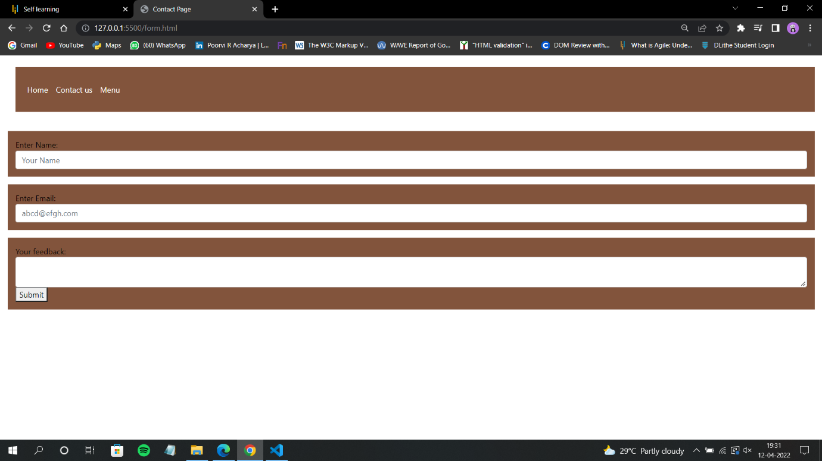

**3.Contact details entered**

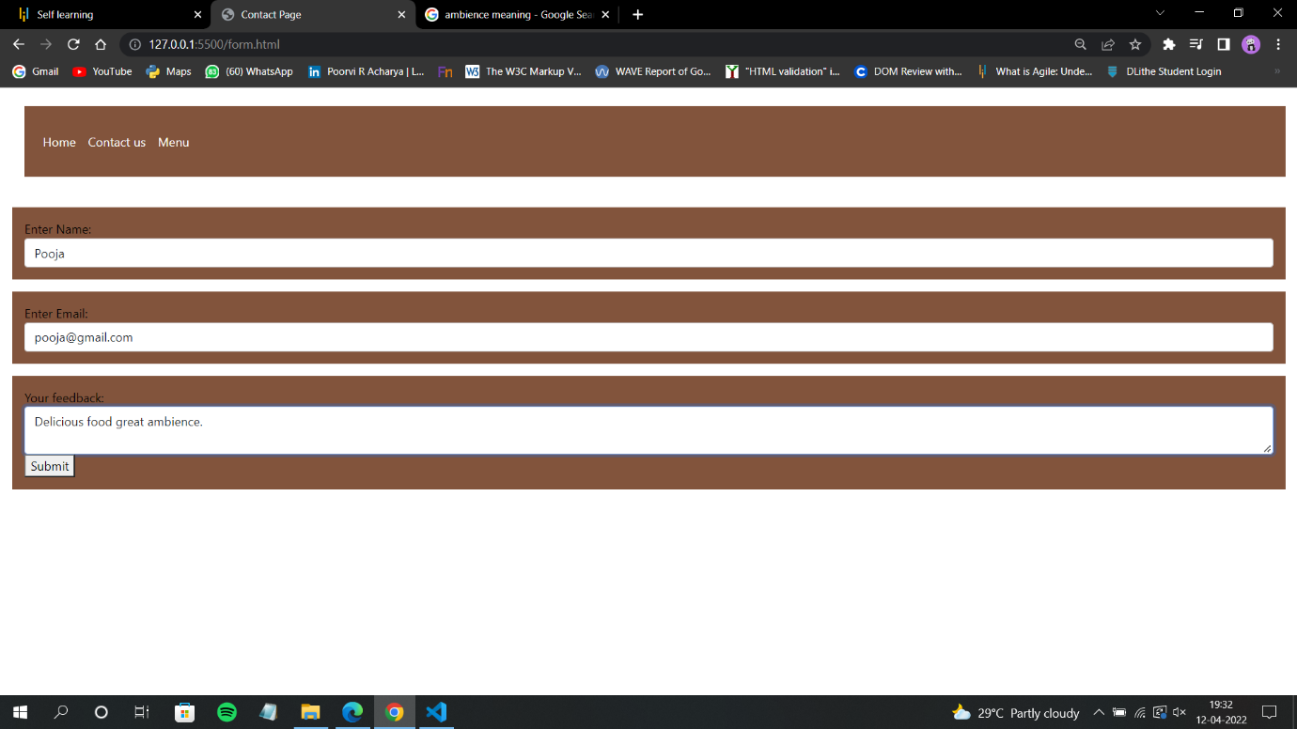

**4.Menu page**